Случайный лес

model = RandomForestRegressor(  
 criterion='absolute_error',  
 n_estimators=900, # 900 - 1000  
 min_samples_leaf=2, # 2 или 1  
 oob_score=True,  
 random_state=1,  
 max_samples=500  
)

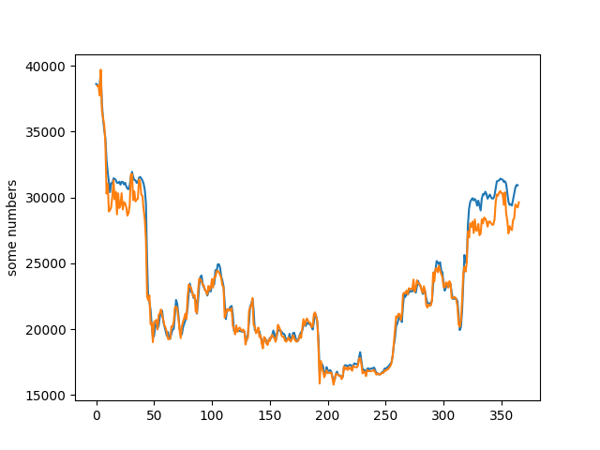

Градиентный буст

model = GradientBoostingRegressor(  
 random_state=1,  
 loss='squared_error',  
 n_estimators = 50,  
 max_depth = 5,  
 criterion = 'friedman_mse',  
 learning_rate= 0.045,  
 min_samples_leaf= 1,  
 min_samples_split= 5  
  
)

